Title: Day 3 – Java API for IoT Smart Home Dashboard
Date: 9 Sept 2025
Name: Nihar Ashraf

Introduction:
On Day-1, I documented the requirements for the IoT Smart Home Dashboard.
On Day-2, I designed the system using UML diagrams (architecture, use case, class diagram).
On Day-3, I focused on implementation of the Device Registration API and setting up the project environment. The goal was to enable customers to register devices (TV, AC, Fan, Light, Robo Vac & Mop) through the Java console application, and store device information in the MySQL database.

Environment Setup:
- Installed and configured Java 23 and IntelliJ IDEA.
- Project created with Maven build system.
- Dependencies added in pom.xml:
- MySQL Connector/J
- jBCrypt (for password hashing)
- MySQL database created:
- Schema: iot_dashboard
- Tables: customers, gadgets.
- Verified database connectivity using a TestDB.java program.

Database Setup:
- Installed MySQL 8.0 on Windows and verified installation using mysql --version.
- Configured MySQL environment variables so mysql command works in CMD.
- Created database schema iot_dashboard.
- Created two tables with proper relationships:
- customers → stores customer details (id, name, email, password hash).
- gadgets → stores gadget details (id, deviceId, type, model, room, status, owner_id foreign key).
- Verified table creation using SHOW TABLES; and DESCRIBE gadgets;.
- Inserted test records to confirm the schema works correctly.
- Created a dedicated user iot_user with privileges for the schema:

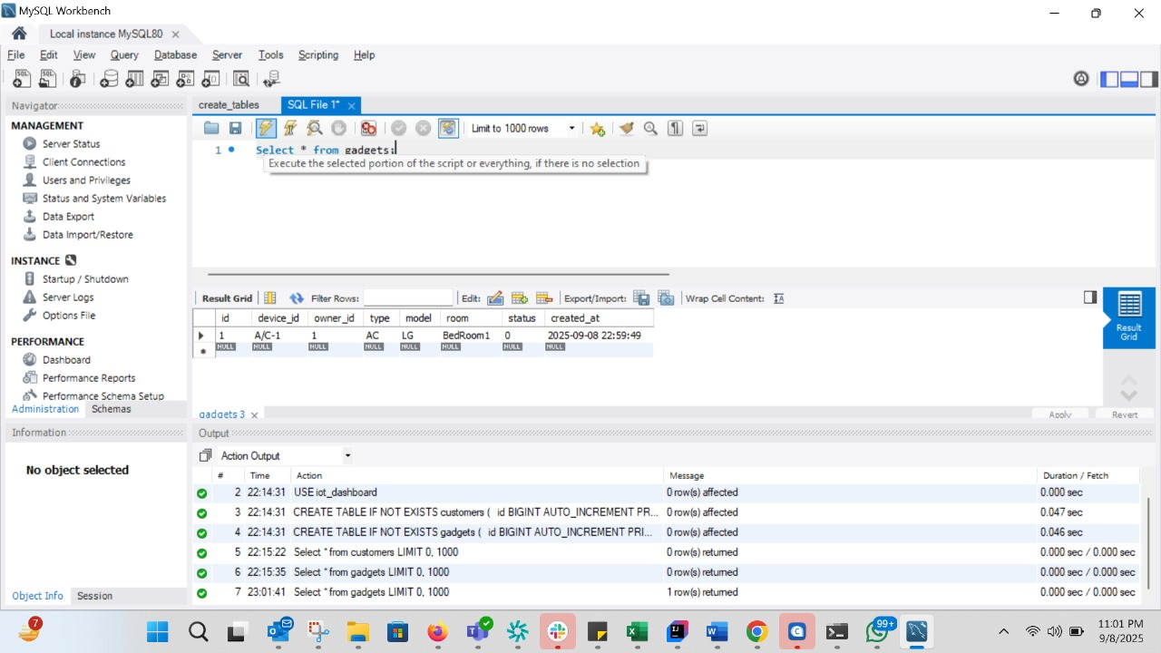

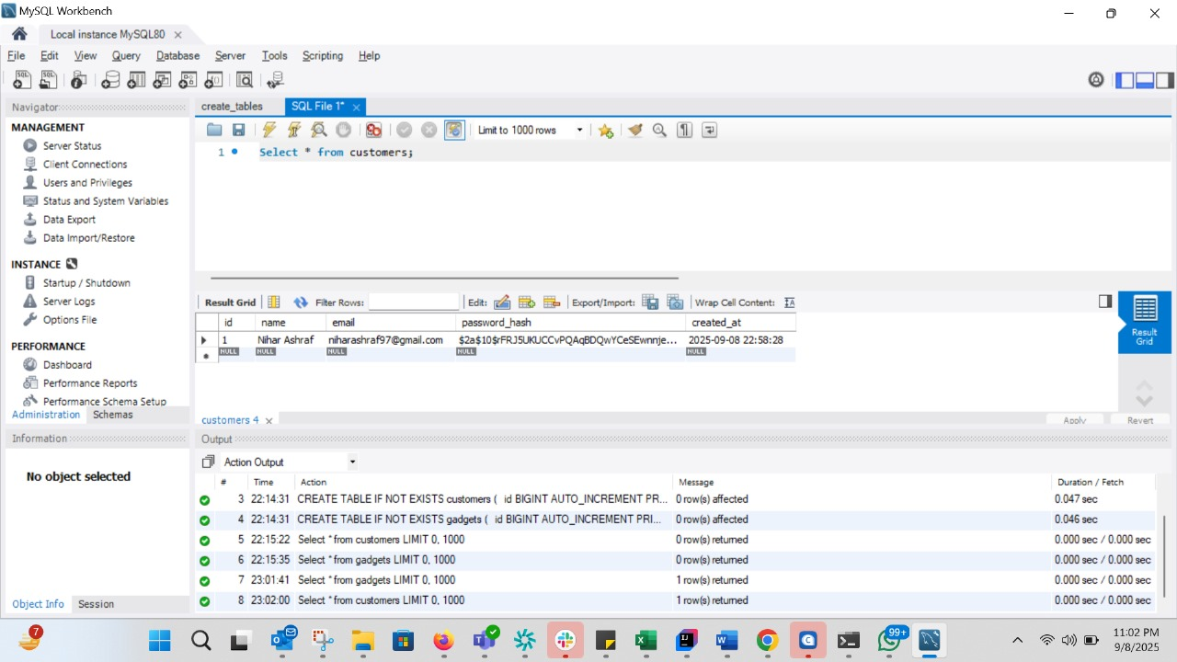

- Updated config.properties in the Java project with database URL, username, and password.
- Tested the connection via TestDB.java class in IntelliJ → confirmed JDBC driver connects successfully.

Implementation Details:
Database Schema
- customers table: stores customer details (id, name, email, password hash).
- gadgets table: stores gadget details (id, deviceId, ownerId, type, model, room, status).

Java Classes Implemented
- Config.java → Reads DB properties.
- DBConnection.java → Manages DB connection.
- Customer.java / Gadget.java → Model classes.
- CustomerDAO.java / GadgetDAO.java → Data access methods for MySQL.
- AuthService.java → Password hashing & verification using BCrypt.
- DeviceRegistrationAPI.java → Handles device registration logic.
- TelemetryService.java → Logs device actions (console print, future: DynamoDB).
- JavaApp.java → Console menu (TUI) where user interacts with system.

Device Registration API Flow
- Customer logs in successfully.
- User selects Control Gadgets (Add Gadget) from the menu.
- Enters device details (deviceId, type, model, room).
- Application validates inputs.
- Device is stored in the gadgets table in MySQL.
- Confirmation message is displayed to the customer.
- Telemetry log is generated (simulating data for DynamoDB).

Testing Performed
- Registered a new customer successfully.
- Logged in with correct email & password.
- Added a new device (tv-1, type: TV, model: Samsung, room: BedRoom1).
- Verified device is stored in MySQL under gadgets table.
- Viewed gadgets (option 4) → device listed with correct status (default OFF).
- Output Screenshot (Sample Console Flow)
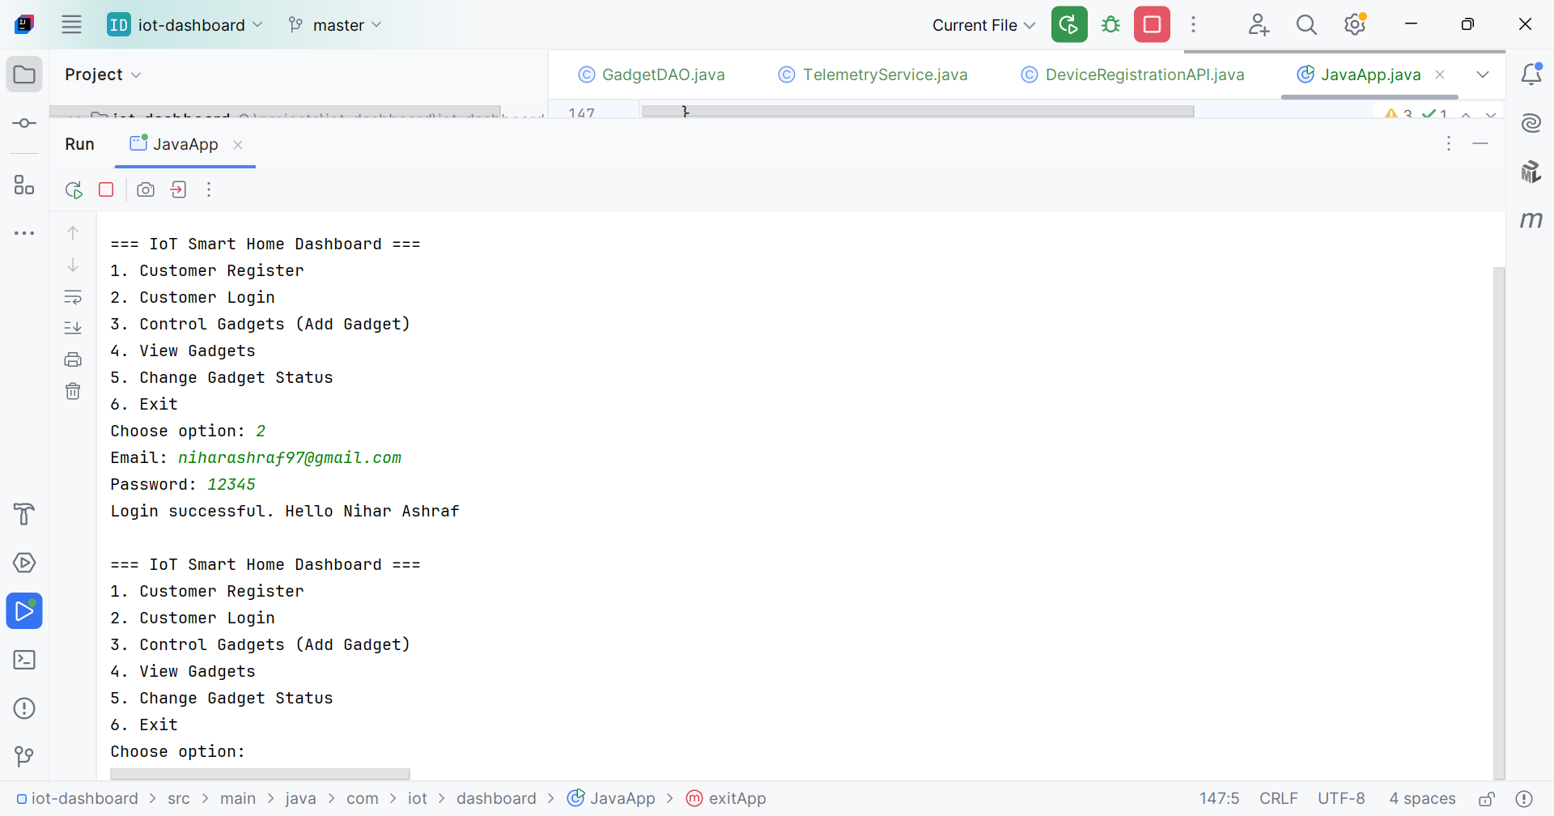
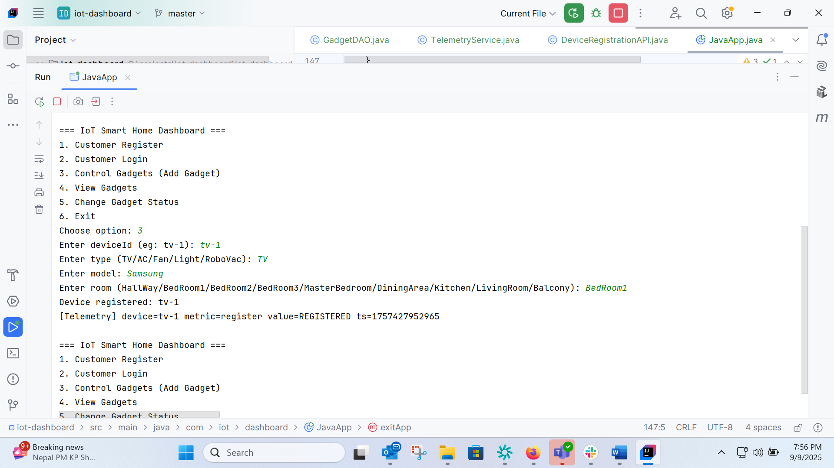
Conclusion:
On Day-3, I successfully implemented the Device Registration API for the IoT Smart Home Dashboard. The Java console application can now register customers, allow login, and let customers add gadgets to their account. Devices persisted in MySQL and telemetry logs are generated.
This completes the first coding milestone of the project.
On Day-4, I will work on Networking (Socket Programming Simulation), where IoT devices will be represented as TCP servers and the Java gateway will communicate with them.

